1. Dataset names

* Alzheimer’s Disease Mortality by State
* Percent of adults aged 18 years and older who have obesity

1. Number of records in the dataset

* 50 states in the US

1. List of features in the dataset

* State
* The number of deaths per 100,000 total population
* The percentage of obesity

1. A short description of the dataset

* The dataset in the Alzheimer’s Mortality by State shows that the number of people who died of Alzheimer’s disease per 100,000 population scale each state in 2019
* The percent of adults aged 18 years and older who have obesity shows that the adults who have the body mass index >= 30

1. Dataset link

* <https://www.cdc.gov/nchs/pressroom/sosmap/alzheimers_mortality/alzheimers_disease.htm>
* <https://nccd.cdc.gov/dnpao_dtm/rdPage.aspx?rdReport=DNPAO_DTM.ExploreByTopic&islClass=OWS&islTopic=&go=GO>

1. Addition

* Dataset visualization

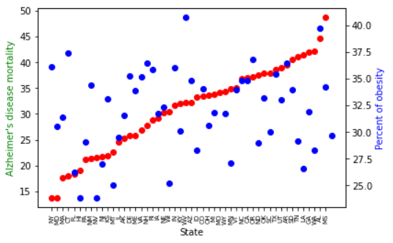

This visualization shows that possible dependency between Alzheimer’s disease mortality and percent of obesity of low correlation. But it’s not sufficient condition. Let’s calculate correlation coefficient.

* Correlation coefficient

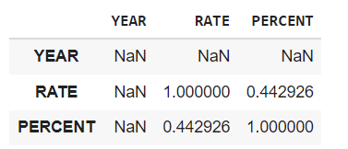

Total value is 0.442926. This is too low value, so we can conclude that there isn’t any dependency between Alzheimer’s disease mortality and percent of obesity. The graph above demonstrated the same result.

* Code link (Google Colab)

<https://colab.research.google.com/drive/1J2-YZWI5KSA5tTbqASUc3LSTSuMPOYBf?usp=sharing>